# **SharePoint Classic Guide**

Redacted: 4/23/21

Sites notes

Finding your site collection

Change the site and page look & feel

Change site title, logo, etc.

Add links to navigation bars

## **Sites notes**

* Your site is a collection. Plan your site organization with your administration. Subsites **may** be created for organizational purposes. We used to start every site by creating a “Document Shares” subsite. Microsoft no longer recommends this practice.
* Currently any Microsoft 365 user can create a new “group site” using the SharePoint tile on the Microsoft 365 dashboard. These sites are connected to Microsoft 365 Groups/Teams and are not as easy to manage. Microsoft assumes that these sites are created for project management by groups of teachers or students. There is little need in these sites for complex permissions setups.
* Whether it is used or not, each school already has a permanent “team site” created by the district. This is the preferred place to house school documents.

## **Finding your site collection**

* In Microsoft 365, use the search box for your official school/department name, as listed on PCSB website
* The standard URL for all schools/departments is:
  + https://pcsb.sharepoint.com/sites/officialschoolname
  + Note: For long school names, abbreviations were used
* Once located, click on the “Follow” in the upper right corner of the site to add it to your “Sites” tile in Microsoft 365

## **Change the site and page look & feel**

**Note:** Customizations apply to all pages on a site. If the main site collection is customized, the customizations **do NOT** transfer to any subsites created under it.

* Customize the home page of the subsite or collection:
  + Remove the “Getting started” tiles by clicking “remove this” above the tiles
  + Edit the contents of the home page by selecting “Edit” in the upper right corner or click “Page” > “edit” in the upper left corner of the web page.



* + - The Page editor ribbon:

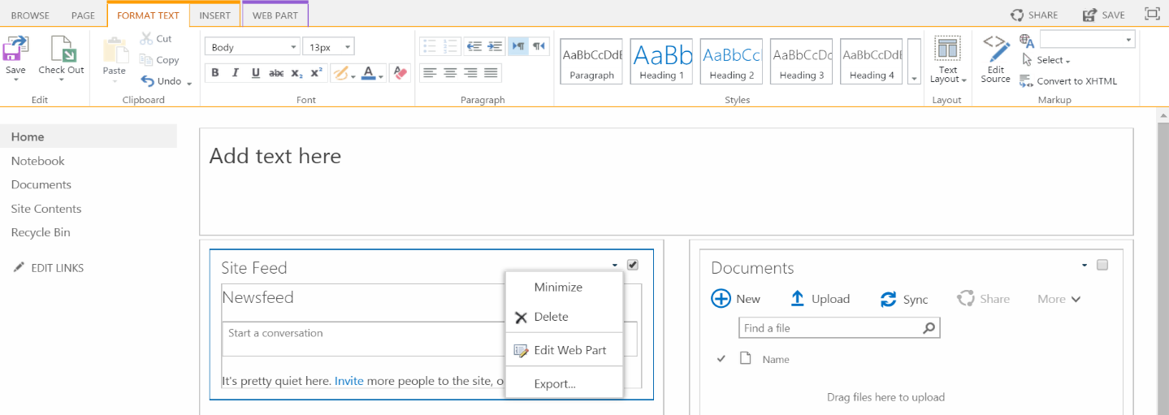

Text edit & formatting

Web parts: “blocks” on a web page that connect to an application on the SharePoint site

Delete Web part:

* + - If desired, add text in the top area of the page by clicking in the box. Use the editing tools in the “Format Text” tab.

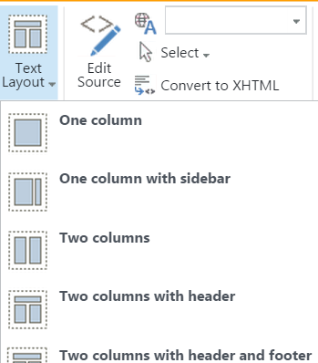

* + - Delete web parts such as the “Newsfeed” by rolling over the web part with your mouse. Click the dropdown menu in the upper right corner of the web part and select “Delete.”
    - To change the column layout of the content on the page, or to add a header or footer, choose “Text layout” on the right side of the “Format text” tab.
    - Additional functionality using the “Insert” tab. To add an app or web part, it must first be added to the site (see below).

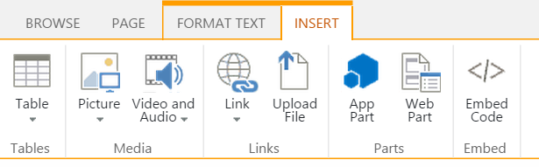

* + - Click “save” in the upper right or left of the page to keep your changes.
  + All pages added to your site can have unique layouts as needed.
* There are two ways to customize the site look:
  + Click the gear menu icon (top/right) > Site Settings > choose “Change the look”
  + Or, click the gear menu > “Change the look”
  + These options are only available in “classic experience” pages.
* When customizing:
  + Select the starting theme by clicking on its image.

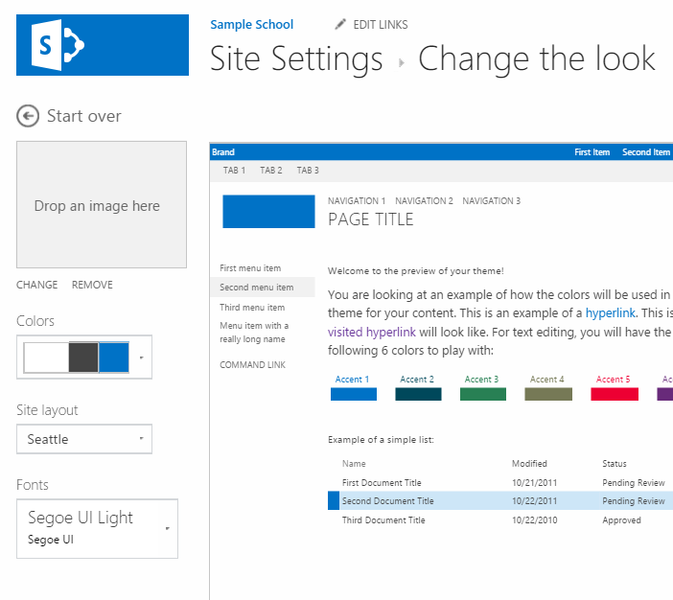

* + Add or change the background image if desired, change the colors and fonts. Preview the options by clicking the dropdown menu for colors and fonts and rolling over each option with your mouse.
  + For Site layout, choose either “Seattle,” which gives you left Quick Launch and top navigation options, or “Oslo,” which moves the Quick Launch to the top navigation and allows more content space in place of left navigation. Since the modern experience has left navigation, it may be more consistent to choose Seattle.
  + Choose “Try it out” on the top, right side of the preview. In the preview window, choose “Yes, keep it,” on the top/right to accept your changes, or “No, not quite there,” to go back and make additional changes.

## **Change site title, logo, etc.**

**Note:** If you change the logo at the site collection level, it will transfer to all subsites created.

* Click the gear menu > “Site Settings” > under “Look and Feel,” (right side), choose “Title, description, and logo.”
* Make the necessary changes. To add or change the logo, under “Insert logo,” choose an image you’re your computer or from one previously uploaded to this site (“From SharePoint”). Select OK

## **Add links to navigation bars**

* On the top or left navigation, click “Edit Links.”
  + To add a link, choose “+ link,” then add a display title and the URL of the site or page you want to link. Click “save” when done.
  + To remove a link, choose the “x” next to the link you want to remove, then click “save.”
* To move the order of the pages, click “Edit links,” click and hold the link title while moving to a different place in the list. Click “save” when done.
* To create drop down lists in the navigation bars:
  + First create a page to serve as the heading landing link, then copy the URL for that page (Gear > Add a page; see below).
  + Create the items you would like to add to the dropdown list (ie: document libraries, pages or lists in SharePoint), or gather your website URL’s to be added to the dropdown.

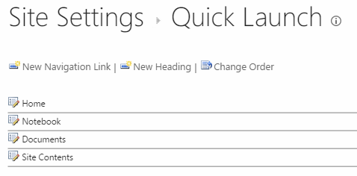

Landing page

Drop down items

* + In the **“Seattle”** site layout, which has both a top navigation and a left navigation “Quick Launch”:
    - Click the gear menu > Site Settings > under “Look and Feel,” choose “Top link bar” or “Quick Launch.”
    - Click “New Heading,” then add the new page URL to create the dropdown list title.
    - Click “New Navigation Link,” add the URL for the item needed in the dropdown list and an optional description, then choose the correct heading to add the link under. Click “OK.”
  + In the **“Oslo”** site layout, which has the “Quick Launch” in place of the top navigation:
    - Click the gear menu > Site Settings > under “Look and Feel,” choose “Quick Launch.”
    - Click “New Heading,” then add the new page URL to create the dropdown list title.
    - Click “New Navigation Link,” add the URL for the item needed in the dropdown list and an optional description, then choose the correct heading to add the link under. Click “OK.”
    - To avoid confusion, it may be better to use Oslo, since the “modern experience” includes a left-side link area that can’t be moved.